
Daffodil International University
Department of Electrical and Electronic Engineering (EEE)
COMPLEX ENGINEERING ASSIGNMENT/PROJECT REPORT COVER PAGE

Project Title or Problem Statement: DUAL-LM393 TEMPERATURE CONTROLLER & SAFETY CLAMP
Course Title: Electronics Laboratory | Course Code: 0714-222
Student ID(s): 251-33-096
251-33-097
251-33-099
Instructor's Name: Engr. Bijoy Sorker |  | Submission Date: 16-08-2026
Batch: 251 | Semester: Summer-2026 | Level-Term: 2-2
Program: B.Sc. in Electrical and Electronic Engineering

Assessment Mapping (Instructor Use Only)

Task Statement | CO No. | Mapped PO | WK | WP/EA | Bloom’s  Taxonomy Domain Level | Assigned Marks | Obtained Marks | Total (30)
Design and formulate a novel idea for an electronic system as a team using basic components and ICs (555 Timer and/or Op-  Amp) | CO1 | PO5 |  | P1, P3 | C6 | 5
Analyze the system mathematically and simulate it to verify its operation under real-world constraints. |  |  |  | P2, P3 | C4 | 10
Build and implement the hardware, troubleshooting practical circuit issues to demonstrate the system working according to the  intended objective. |  |  |  | P2, P3 | C6 | 12
Prepare and evaluate a technical report and a presentation in a team to explain your system, results,  and collective contribution. | CO2 | PO9 |  |  | C5 | 13

Signature of the Instructor

Course Code: | 0 | 7 | 1 | 4 | - | 2 | 2 | 2 | Course Title: | Electronics Laboratory

Addressing the Range of Complex Engineering Problem Solving (WP)
Attribute (WP) | Mapped | Please write your comments against each attribute mapped in the space below. Attach more sheets if necessary. (Optional)
P1: Depth of knowledge required | √ | The project requires students to understand and apply knowledge of basic electronic components, ICs, sensors, and microcontrollers. They must integrate theory with practical application, which ensures a deep understanding of electronics concepts and their real-life usage.
P2: Range of conflicting requirements | √ | Students must manage wide-ranging conflicting design considerations and real-world technical issues while building the hardware prototype. They are required to balance competing factors such as component compatibility, cost-efficiency, power stability, and physical wiring constraints to ensure the system works effectively according to its intended objective.
P3: Depth of analysis required | √ | Students must mathematically analyze their system, perform simulations, and compare results with expected performance. This involves critical thinking, problem-solving, and technical analysis, fulfilling the requirement for thorough analytical depth.
P4: Familiarity of issues
P5: Extent of applicable codes
P6: Extent of stakeholder involvement and conflicting requirements
P7: Interdependence

Electronics Laboratory – Complex Engineering Project Evaluation Rubric (Maximum Marks: 40)
Task | Excellent (90–  100%) | Good (70–89%) | Satisfactory (50–69%) | Needs Improvement (<50%) | Marks
Idea/Concept & Novelty | Idea is highly innovative, clearly defined, and well-justified | Idea is moderately innovative and feasible | Idea is basic, limited novelty | Idea is unclear or not feasible | 2
Circuit/System Design | Complete, well-structured design integrating components, ICs; clear schematic provided | Mostly complete design with minor missing details; schematic mostly clear | Design is partially complete or missing key connections | Design incomplete or incorrect; schematic missing | 3
Mathematical Analysis & Simulation | Thorough analysis, correct calculations, clear simulation results fully explained | Moderate analysis, minor errors, simulation results mostly correct | Basic analysis, some errors, limited simulation results | Analysis missing or incorrect, simulation not done | 10
Hardware Implementation & Functionality | Hardware built successfully; system works fully as intended | Hardware mostly works; minor issues in functionality | Hardware partially works; several functional issues | Hardware not built or does not work | 12
Report & Presentation | Well-structured, clear, complete report; presentation is professional and informative | Report mostly complete with minor gaps; presentation understandable | Report incomplete; presentation unclear | Report missing or very poor; no presentation slide | 13

DUAL-LM393 TEMPERATURE CONTROLLER
& SAFETY CLAMP
Project Report

1. Abstract
This project presents a three-stage temperature controller and safety-clamp system based on two LM393 dual comparator ICs, a TMP36 temperature-sensing characteristic, an NE555 low-frequency oscillator, and an NPN transistor switching stage. A 10 kΩ potentiometer is used as a simulator for the temperature-dependent input voltage. The system defines three temperature levels: 30 °C for Stage 1 warning, 60 °C for active alarm and cooling, and 100 °C for an independent dual master shutdown clamp. The corresponding sensor voltages are 0.80 V, 1.10 V, and 1.50 V. Between 60 °C and 100 °C, the fan is activated and the red LED and buzzer are driven by an approximately 1.5 Hz NE555 oscillator. At or above 100 °C, the clamp comparators force the stage-control nodes LOW.

2. Introduction

2.1 Background
Temperature monitoring and protection are important in electronic systems because excessive heat can affect normal operation and may damage components. This project uses different temperature levels to provide a clear response as the temperature increases. The system first gives a warning, then activates cooling and an alarm, and finally provides a master shutdown at a higher temperature. The design combines temperature-voltage conversion, LM393 comparator threshold detection, LED indication, NE555 timing, and transistor switching in one practical control system.

2.2 Motivation
The main motivation of this project is to develop a simple and practical temperature protection system using commonly available electronic components. It demonstrates how a changing temperature signal can be converted into voltage and compared with selected reference levels to control different outputs. The project also demonstrates warning indication, an audible alarm, automatic fan cooling, and a final shutdown function. These features make the project useful for understanding basic temperature monitoring and safety-control circuits.

2.3 Objectives
1. Simulate the temperature input with a 10 kΩ potentiometer over 0–5 V.
2. Generate a Stage 1 warning at 30 °C (0.80 V).
3. Activate the alarm and cooling stage at 60 °C (1.10 V).
4. Provide independent master shutdown at 100 °C (1.50 V).
5. Generate an approximately 1.5 Hz flashing/beeping output with the NE555.
6. Check LED, comparator, and transistor currents using the stated component values.

3. Methodology

3.1 Block Diagram
[10 kΩ Temperature Simulator / V_IN]
↓
[LM393 IC1 — Stage 1 & Stage 2 Comparators]
↓ ↓
Yellow LED N_STAGE2
↓
┌─────────────┴─────────────┐
↓ ↓
[2N2222 Fan Driver] [NE555 Astable]
↓ ↙ ↘
5 V Fan Red LED Piezo Buzzer
[LM393 IC2 — Dual 100 °C Clamp] → Master Shutdown

3.2 Circuit Diagram
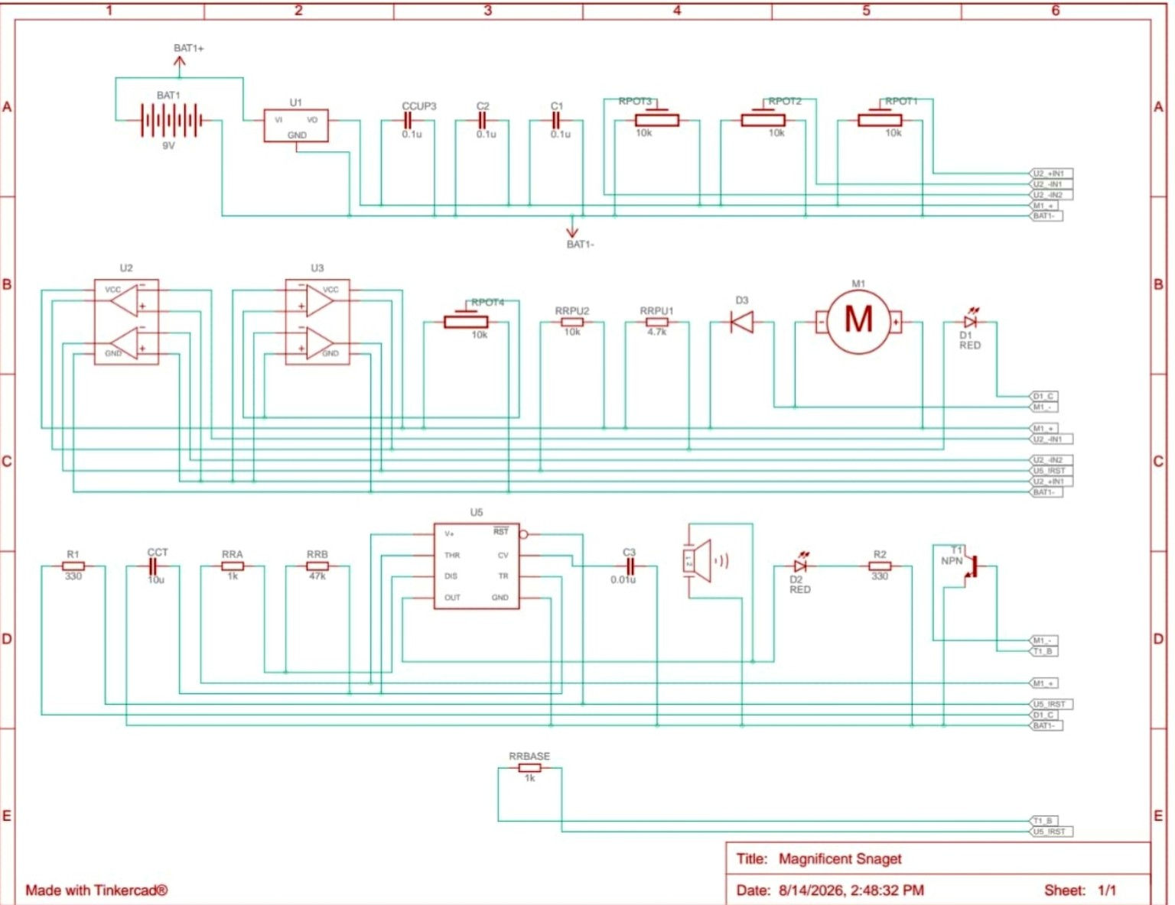
Figure 1. Complete circuit diagram of the Dual-LM393 Temperature Controller & Safety Clamp.

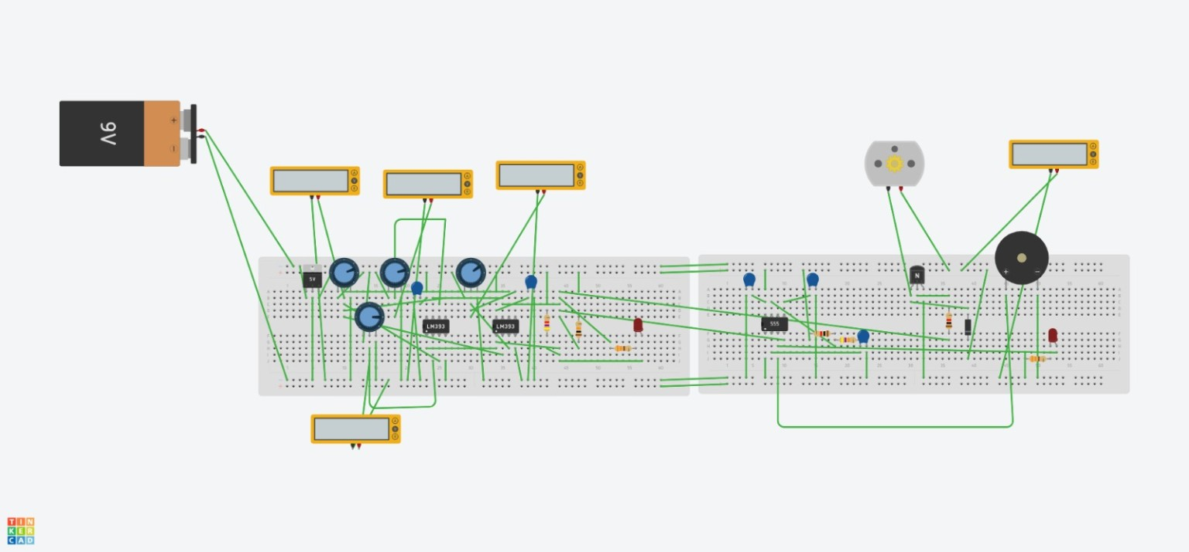
Figure 2. Breadboard implementation / simulation view of the temperature-controlled fan and alarm circuit.

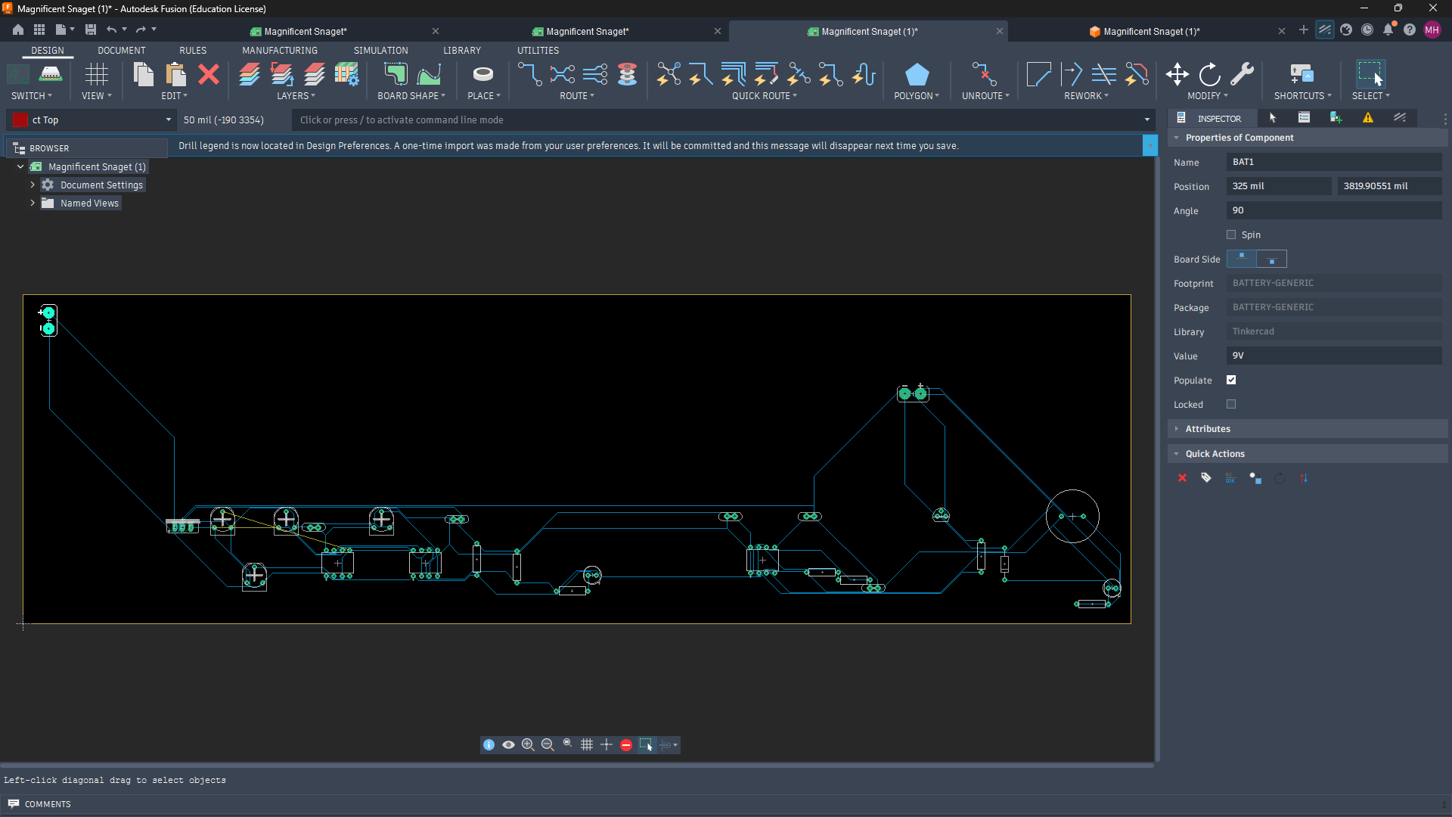
Figure 3. PCB implementation / simulation view of the temperature-controlled fan and alarm circuit.

3.3 Working Principle
The input voltage follows the specified TMP36 transfer function: V_OUT = 0.50 V + (10 mV/°C × T). The 10 kΩ potentiometer reproduces this voltage for testing. IC1 compares V_IN with 0.80 V and 1.10 V references. IC2 compares V_IN with the 1.50 V reference using two independent clamp channels. The Stage 2 node controls the NE555 RESET input and the NPN transistor base through a 1 kΩ resistor.

3.4 Components List
Component | Quantity | Purpose
9 V battery | 1 | Power source
LM7805 voltage regulator | 1 | 5 V regulated supply
LM393 dual comparator ICs | 2 | Temperature threshold detection
NE555 timer IC | 1 | Alarm oscillator
10 kΩ potentiometers | 4 | Reference/sensor-voltage adjustment
4.7 kΩ resistor | 1 | Circuit bias/current limiting
1 kΩ resistors | 2 | Timing/current limiting
10 kΩ resistors | 1 | Pull-up/bias networks
47 kΩ resistor | 1 | NE555 timing network
330 Ω resistors | 2 | LED current limiting
Capacitors | 5 | Supply decoupling and timing
Diodes | 1 | Protection/flyback
NPN transistor | 1 | Fan/motor switching
DC motor/fan | 1 | Cooling output
Buzzer | 1 | Audible alarm
LED indicators | 2 | Status indication
Breadboards | 2 | Circuit assembly
Jumper wires | As required | Circuit connections

3.5 Operating Truth Table
V_IN | Temperature | N_STAGE1 | N_STAGE2 | Yellow LED | Red LED | Buzzer | Fan | State
< 0.80 V | < 30 °C | 0 V | 0 V | OFF | OFF | OFF | OFF | System Idle
0.80–1.10 V | 30–60 °C | +5 V | 0 V | ON | OFF | OFF | OFF | Stage 1 Warning
1.10–1.50 V | 60–100 °C | +5 V | +5 V | OFF | BLINKING | PULSING | ON | Stage 2 Active Alarm & Cooling
≥ 1.50 V | ≥ 100 °C | 0 V | 0 V | OFF | OFF | OFF | OFF | Over-Temp Master Shutdown

4. Results & Discussion

4.1 Calculation Results
The calculated results support the selected operating thresholds and alarm timing. Using VOUT = 0.50 + 0.010T, the reference voltages are 0.80 V at 30 °C, 1.10 V at 60 °C, and 1.50 V at 100 °C.
For the NE555 astable stage, RA = 1 kΩ, RB = 47 kΩ and CT = 10 µF give f = 1.44/[(RA + 2RB)CT] ≈ 1.52 Hz, so the alarm output is approximately 1.5 Hz.
Therefore, the expected result is: below 30 °C the system remains idle; from 30–60 °C the Stage 1 warning operates; from 60–100 °C the fan and alarm operate; and at or above 100 °C the master shutdown condition is activated.

4.1.1 Temperature-to-Voltage Mapping (TMP36 Transfer Function)
• Formula: V_OUT = 0.50 V + (10 mV/°C × Temperature in °C)
• Stage 1 Trigger (30 °C): V_REF1 = 0.50 V + (0.010 V/°C × 30 °C) = 0.80 V
• Stage 2 Trigger (60 °C): V_REF2 = 0.50 V + (0.010 V/°C × 60 °C) = 1.10 V
• Master Shutdown Clamp (100 °C): V_REF3 = 0.50 V + (0.010 V/°C × 100 °C) = 1.50 V

4.1.2 NE555 Low-Frequency Astable Oscillator Calculations
• Component Values: R_A = 1 kΩ, R_B = 47 kΩ, C_T = 10 µF (0.00001 F)
• High Output Time (t_HIGH): 0.693 × (R_A + R_B) × C_T = 0.693 × 48,000 Ω × 0.00001 F = 0.3326 s
• Low Output Time (t_LOW): 0.693 × R_B × C_T = 0.693 × 47,000 Ω × 0.00001 F = 0.3257 s
• Total Period (T): t_HIGH + t_LOW = 0.3326 s + 0.3257 s = 0.6583 s
• Oscillation Frequency (f): 1.44 / [(R_A + 2 × R_B) × C_T] = 1.44 / [95,000 × 0.00001] = 1.5158 Hz (~1.5 Hz)
• Duty Cycle (D): [ (R_A + R_B) / (R_A + 2 × R_B) ] × 100% = (48 / 95) × 100% = 50.53%

4.2 Simulation
The simulation result shows the temperature-control circuit operating with reference and sensor voltages set for the selected thresholds. The simulation display shows 0.80 V, 1.10 V and 1.50 V levels, with a 5.00 V supply.
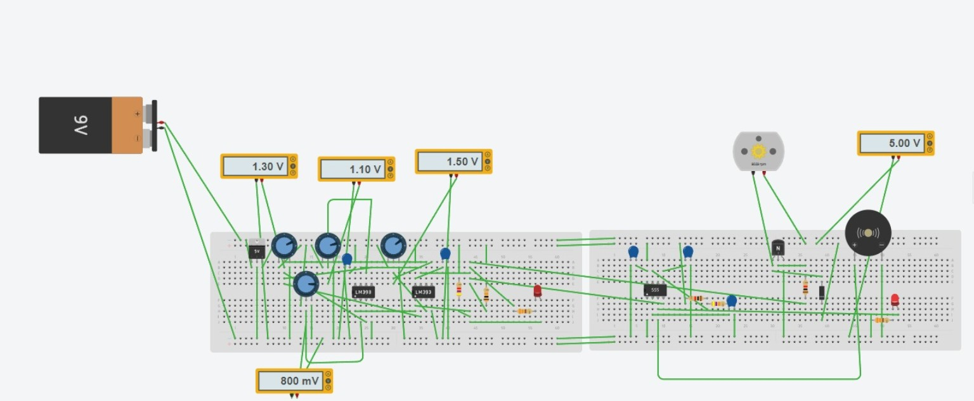
Figure 4. Simulation result of the temperature-controlled fan and alarm circuit.

4.3 Experimental
The experimental circuit was assembled on breadboards and tested using a digital multimeter. The photograph shows the physical implementation and a measured voltage of approximately 1.487 V.
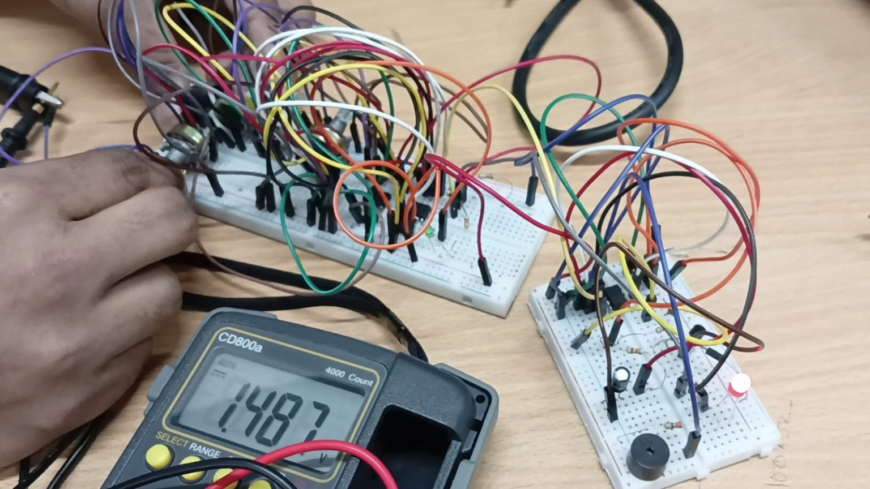
Figure 5. Experimental setup and measured result of the temperature-controlled fan and alarm circuit.

5. Conclusion
The Dual-LM393 Temperature Controller and Safety Clamp successfully demonstrates three-stage temperature monitoring and protection. The system provides a warning at 30 °C, activates the alarm and cooling fan at 60 °C, and provides master shutdown at 100 °C. The NE555 generates approximately 1.5 Hz alarm signal, while the LM393 comparators control the different temperature stages. The experimental measurement of approximately 1.487 V was also close to the 1.50 V shutdown reference. Overall, the project demonstrates a practical combination of temperature threshold detection, alarm indication, and automatic cooling control.

6. References
1. Texas Instruments. LM393 Dual Differential Comparator — product information and datasheet. https://www.ti.com/product/LM393
2. Texas Instruments. NE555 Precision Timers — product information and datasheet. https://www.ti.com/product/NE555
3. Analog Devices. TMP36 Voltage Output Temperature Sensor — product information and datasheet. https://www.analog.com/en/products/tmp36.html
4. onsemi. 2N2222A Small Signal Switching Transistor — datasheet. https://www.onsemi.com/download/data-sheet/pdf/2n2222a-d.pdf

